Online Booking

Database class project 2021/2022

|  |  |  |  |  |
| --- | --- | --- | --- | --- |
| Student Name in English | Student Name in Arabic | Student ID | Section | Work percentage |
| Amr Salman | عمرو منهل احمد سلمان | 11941434 | 8:00 – 9:30 | 50% |
| Mohamed Haitham Hinnawi | "محمد هيثم " محمد كامل "حلمي حناوي | 11924343 | 8:00 – 9:30 | 50% |
|  |  |  |  |  |

Date/time

---------------------------------------------This section is intended for the Instructor---------------------------------------

|  |  |
| --- | --- |
| **Topic** | **Mark** |
| Project Requirements and Modeling |  |
| Correctness of Database mapping |  |
| Functional Dependency and Normalization |  |
| Project Tools |  |
| Project Discussion |  |
| Project Completeness |  |
| Project Output Results or reporting (JasperReport, charts, graphs, etc.) |  |
| Project Administration and Management |  |
| Project Report |  |
| Project Idea |  |
| Project Complexity |  |
| Team work |  |
|  |  |
|  |  |
|  |  |

**Abstract:**

In the beginning, the idea of our project was based on designing an application for booking flights and hotel rooms, and we chose it to help and solve the problem of tourists who want to travel and have a great time.

This application enables the user to reach the various destinations he wants to go to and also book different hotel rooms wherever he wants.

**Table of contents:**

* Introduction …………………………………………………………. 4
* Project Requirements …………………………………………………………. 5
* Functional Dependency ………………………………………………………… 6
* Check BCNF ……………………………………………………. 12
* Project UML ………………………………………………………… 13
* Project EER ………………………………………………………….. 14
* Tools used for project ………………………………………………………… 15
* GUI Discussion ………………………………………………………. 15

1. Sign in……………………………………………………………………….………..15
2. Sign up ……………….………………………………………………………………16
3. Forgot password………………………………………………………………….17
4. Main Menu………………………………………………………………………….18
5. Profile information ……………………………………………………………...19
6. Fill in this information ………………………………………………………….20
7. All trips ………………………………………………………………………….…….21
8. Ticket information………………………………………………………………..22
9. Ticket information2……………………………………………………………..23
10. Hotel Address……………………………………………………………………...24
11. Hotels…………………………………………………………………………………..25
12. Book Date…………………………………………………………………………….26
13. Rooms………………………………………………………………………………….27
14. Room Information……………………………………………………………….28
15. Room Information………………………………………………………………..29

* References..…………………………………………………………………………………………30
* Conclusion………………………………………………………………………………………….31

**Introduction:**

One of the problems that tourists face and make them reluctant to make a decision is their lack of knowledge of how to book, from where and what the cost is for that.

So, in this application, we have solved this problem. It is easy for them to make the reservation process, and they can also do it in the decision without going anywhere and without any intermediary that can exploit them financially because this application displays the price of each flight and the price of each hotel room if desired. In the reservation and the type of reservation.

This application also displays reports to the user about flights and hotel rooms that may help them make the right decision they want.

This application also enjoys high security and privacy for users, as it contains a user name that distinguishes him from others and a password, and he can update it if he forgot it through a special code sent to him on the email.

**Project Requirements:**

This is a tourism company that book a plane ticket and room in many hotels and several countries

For each customer the database maintains information on customer’s ID , name[First, Second, Third, Last], sex, passport number, country, phone number, birthdate , Email, username and password .

For each hotel the database has information about hotel’s ID, name, address [Country, City, Street] and evaluation, and every hotel has many rooms, so the hotel is related with room in HAS [1 : N] .

Each Room has ID, number of people, price per night and type.

And a room can reserved by many people in different time and customer can reserve many rooms so the room is related with customer in Room reservation [N: M] and it has attributes price per stay, check in and check out.

For each flight the database has information about Flight’s ID, departure from [From] [Country, City, Airport] , destination [to] [Country, City, Airport],time [Hour, Date],Airline Company ,plane number and price.

And a flight can reserved by many people in different time and customer can reserve many flight so the flight is related with customer in Ticket [N: M] and it has attributes ticket number.

**Functional Dependency:**

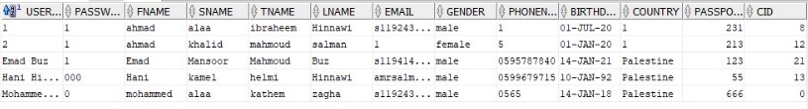

according to Data::

1. USER_NAME 🡪 password
2. USER_NAME 🡪 fname
3. USER_NAME 🡪 sname
4. USER_NAME 🡪 tname
5. USER_NAME 🡪 Lname
6. USER_NAME 🡪 email
7. USER_NAME 🡪 gendar
8. USER_NAME 🡪 phone number
9. USER_NAME 🡪 date of birth
10. USER_NAME 🡪 country
11. USER_NAME 🡪 passport number
12. USER_NAME 🡪 CID
13. fname🡪 date of birth
14. fname🡪 country
15. fname🡪 password
16. sname🡪 email
17. sname🡪 gendar
18. tname🡪 password
19. email🡪 sname
20. email🡪 gendar
21. phone number 🡪 password
22. phone number 🡪 fname
23. phone number 🡪 sname
24. phone number 🡪 tname
25. phone number 🡪 Lname
26. phone number 🡪 email
27. phone number 🡪 gendar
28. phone number 🡪 USER_NAME
29. phone number 🡪 date of birth
30. phone number 🡪 country
31. phone number 🡪 passport number
32. phone number 🡪 CID
33. date of birth 🡪 password
34. date of birth 🡪 fname
35. date of birth🡪 country
36. passport number 🡪 password
37. passport number 🡪 fname
38. passport number 🡪 sname
39. passport number 🡪 tname
40. passport number 🡪 Lname
41. passport number 🡪 email
42. passport number 🡪 gendar
43. passport number 🡪 phone number
44. passport number 🡪 date of birth
45. passport number 🡪 country
46. passport number 🡪 USER_NAME
47. passport number 🡪 CID
48. CID 🡪 password
49. CID 🡪 fname
50. CID 🡪 sname
51. CID 🡪 tname
52. CID 🡪 Lname
53. CID 🡪 email
54. CID 🡪 gendar
55. CID 🡪 phone number
56. CID 🡪 date of birth
57. CID 🡪 country
58. CID 🡪 USER_NAME
59. CID 🡪 passport number

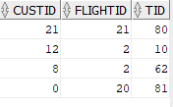

according to Data:

1. TID🡪 custid
2. TID🡪 flightid
3. custid 🡪 TID
4. custid 🡪 flightid

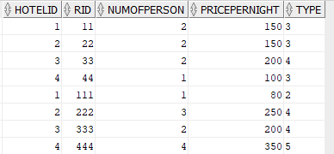

according to Data:

1. RID🡪 hotelid
2. RID🡪 numofperson
3. RID🡪 Pricepernight
4. RID🡪 type
5. Pricepernight🡪 type
6. Pricepernight🡪 numofperson

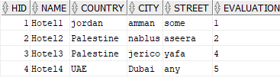

1-name🡪 HID

2- name🡪 city

3- name🡪 country

4- name🡪 street

4- name🡪 evalution

5- city 🡪 HID

6- city 🡪 name

7- city 🡪 country

8- city 🡪 street

9- city 🡪 evalution

10- street 🡪 HID

11- street 🡪 name

12- street 🡪 country

13- street 🡪 city

14- street 🡪 evalution

10- evalution 🡪 HID

11- evalution 🡪 name

12- evalution 🡪 country

13- evalution 🡪 city

14- evalution 🡪 street

15- name 🡪 name

16- HID 🡪 city

17- HID e🡪 country

18- HID 🡪 street

19- HID 🡪 evalution

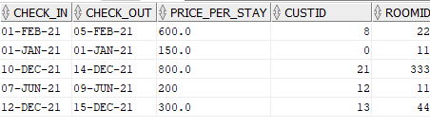

according to Data:

1-check_in🡪 check_out

2- check_in🡪 price_per_stay

3- check_in🡪 custid

4-check_in🡪 roomid

5- check_out 🡪 check_in

6- check_out 🡪 price_per_stay

7- check_out 🡪 custid

8- check_out🡪 roomid

9- price_per_stay 🡪 check_in

10- price_per_stay 🡪 check_out

11- price_per_stay 🡪 custid

12- price_per_stay 🡪 roomid

13- custid🡪 check_in

14- custid🡪 check_out

15- custid🡪 price_per_stay

16- custid🡪 roomid

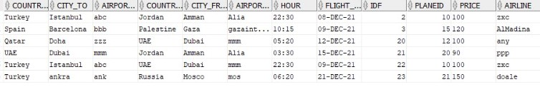

according to Data:

1-city_to🡪 airport_to

2-city_to🡪 Hour

3-city_to🡪 Planeid

4- city_to🡪price

5- city_to🡪 airline

6- airport_to 🡪 city_to

7- airport_to 🡪 Hour

8- airport_to 🡪 Planeid

9- airport_to 🡪price

10- airport_to 🡪 airline

11-country_from🡪 city_from

12- country_from🡪 airport_from

13- city_from🡪 airport_from

14- city_from🡪 country_from

15- airport_from🡪 city_from

16- airport_from🡪 country_from

17-Hour🡪 country_to

18- Hour🡪 city_to

19- Hour🡪 airport_to

20- Hour🡪 Planeid

21- Hour🡪 price

22- Hour🡪 airline

23-IDF🡪 country_to

24- IDF🡪 city_to

25- IDF🡪 airport_to

26- IDF🡪 country_from

27- IDF🡪 city_from

28- IDF🡪 airport_ from

29- IDF🡪 Hour

30- IDF🡪Flight_date

31- IDF🡪 price

32- IDF🡪 airline

33- IDF🡪 Planeid

34- Planeid🡪 price

35- Planeid🡪 airline

36- Planeid🡪country_to

37- Planeid🡪city_to

38- Planeid🡪 airport_to

39- Planeid🡪 Hour

40- airline🡪 price

41- airline🡪 Planeid

42- airline🡪 Hour

43- airline🡪 country_to

44- airline🡪 city_to

45- airline🡪 airport_to

**Now Checking the BCNF and normalization process**.

Customer have a BCNF because it have a two FD cid and username.

Hotel have a BCNF with HID and Name.

Room have a BCNF with RID .

Flight have a BCNF with FID .

Ticket have a BCNF with TID and Custid.

ROOM_RESERVATION a have a BCNF with custid and price_per_stey.

**Project UML:**

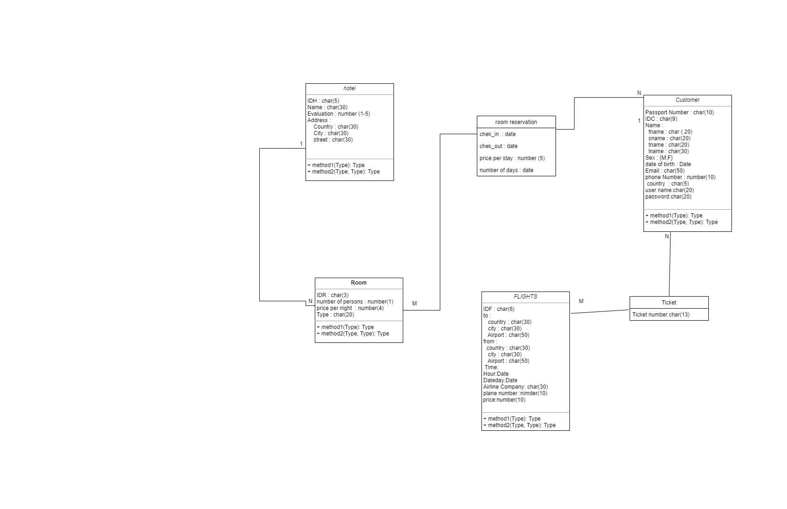

**Project EER:**

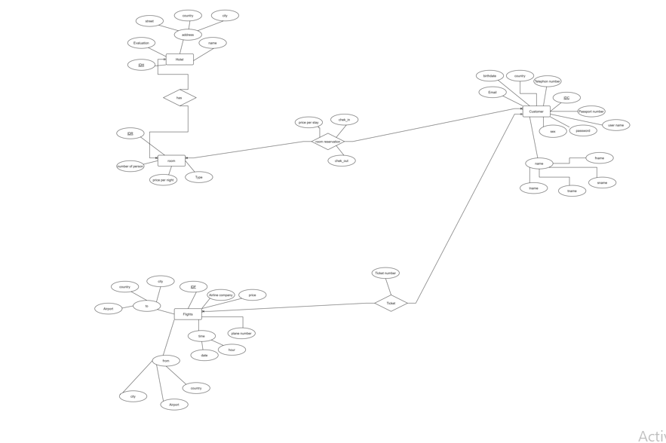

**Tools used for Project:**

* Apache NetBeans IDE 12.4.
* SQL Developer.
* TIBCO Jaspersoft Studio-6.7.1
* Draw.IO

**GUI Discussion:**

**Sign in:**

This is the start-up window of the application, where it displays the login to users. If he has an account, he logs in through his user name and password. If he does not have an account, he clicks on Create a new account, which takes him to the create a new account plane.

If the user forgets the password, he clicks "Forgot Password", it will take him to the "Forgot Password" window.

If he logged in correctly, he will go to the main plane. 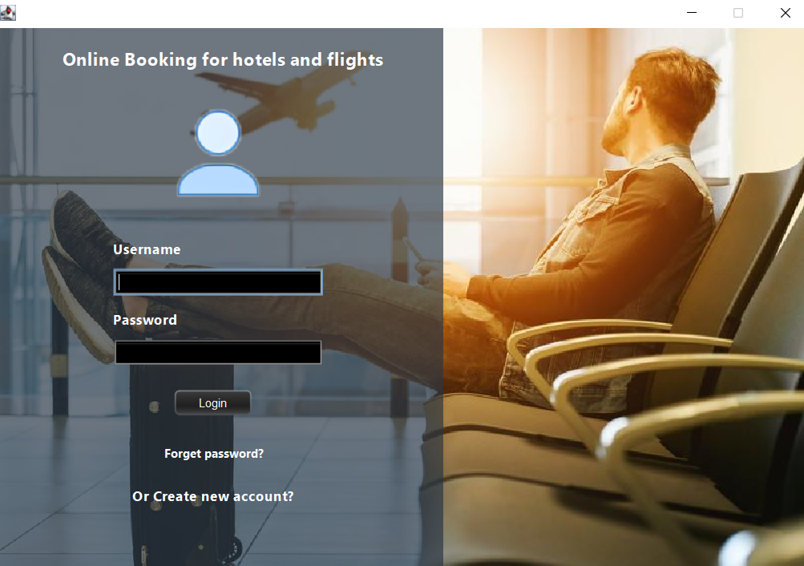

**Sign up:**

The new user will fill in the basic information such as name, passport number, phone number, gender, date of birth and the country of his nationality, and also create a user name, provided that this name is unique, and a message will appear to him that this name has already been used and he will create a password Its own secret, and when you press sign up it goes to the main page.

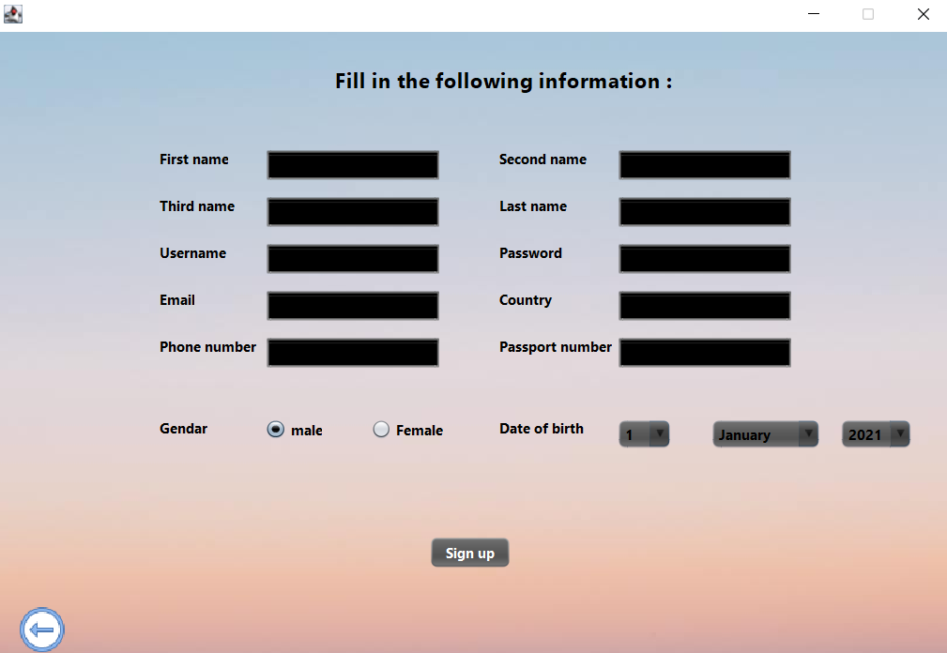

**Forgot password Frame:**

This window is intended for users who have forgotten their password and want to reset their password.

They will initially enter the user's name and press next. If the name he entered is correct, he will be asked to enter the email, and if the name is incorrect, a message will appear to him.

When entering the email, he will make sure that it is the same email that he entered when creating his account. If it is not the same, a message will appear to him, and if it matches, he will send a message to him containing a code.

After that, he will enter the code, and it will be verified that it is correct. If it is correct, it will move to the next page, and if it changes, a message will appear to him explaining that they threw it incorrectly.

Finally, he will enter the new password and will retype it and confirm it. When he clicks on Reset password, and if it does not match, a message will appear to him, and if it matches, he will change the password.

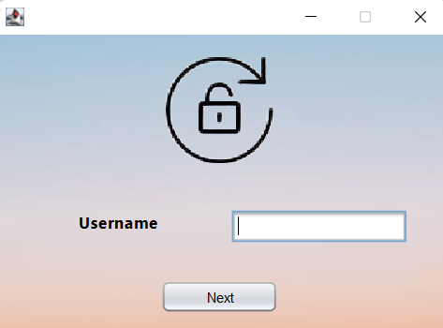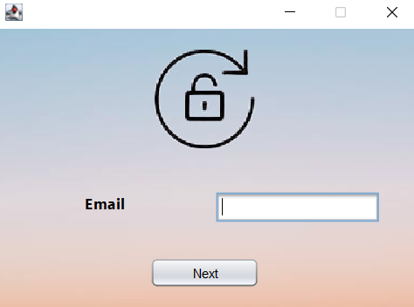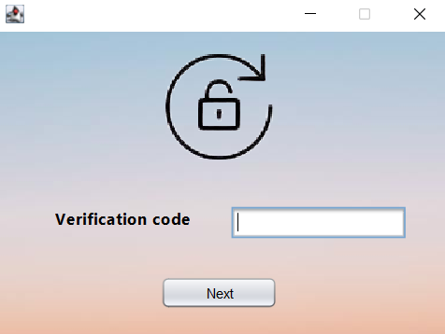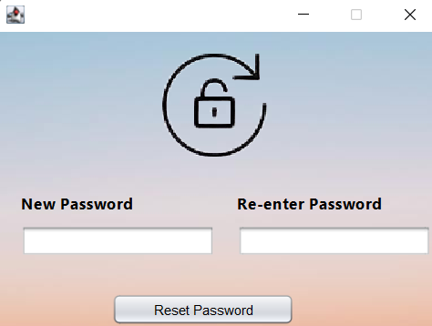

**Main Menu:**

The user will choose what he wants (booking a room, booking a flight, displaying reservation information or his personal information).

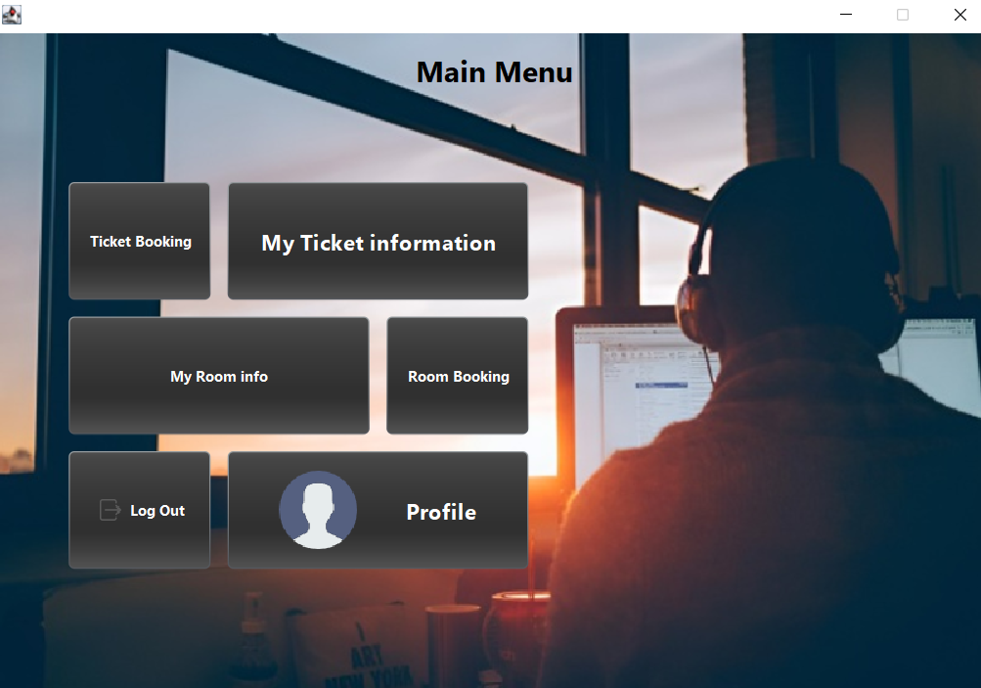

**Profile information:**

It appears when you click on profile in the main menu.

Here, the personal information that the user stored when creating his account is displayed.

And when you click on the main menu, it goes to it

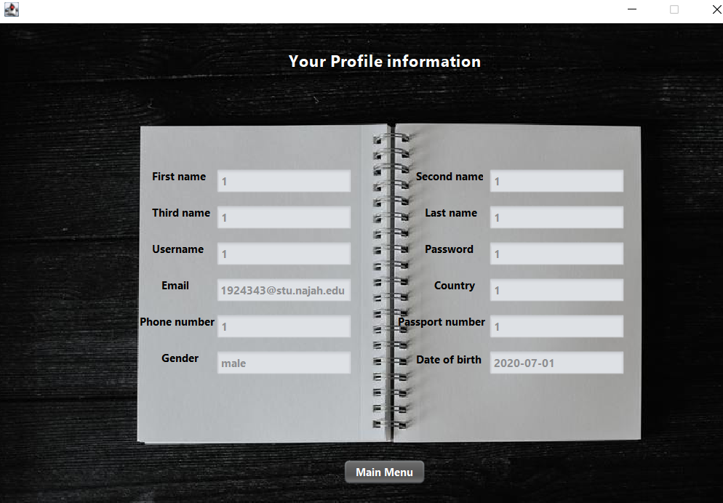

**Fill in this information:**

It appears when you click to reserve a ticket in the main menu.

Here you choose the place you will leave from and the destination you want to go to (country, city, airport)

When you click on Next, a new window will appear to him containing a schedule containing all the flights that are between the place he chose to leave from and the destination.

At the bottom of the right screen it contains an Apple in the form of three shatters. When you click on it, it goes to the main menu, and the bottom left contains an Apple in the form of an arrow that returns to the page before it.

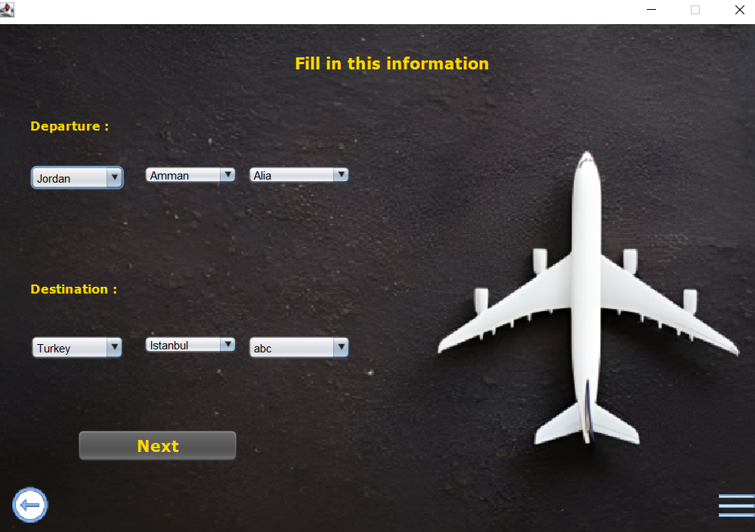

**All trips:**

It appears when you click on the next in Fill in this information.

All flights that depart from the site to the destination desired by the two predetermined are displayed on the page before it with information about each flight (time, date, price and airline).

The flight you want is selected by clicking on it in the table, and when you click on submit booking, it is stored in the database and reserved, then you go to the main menu.

At the bottom of the right screen it contains an Apple in the form of three shatters. When you click on it, it goes to the main menu, and the bottom left contains an Apple in the form of an arrow that returns to the page before it.

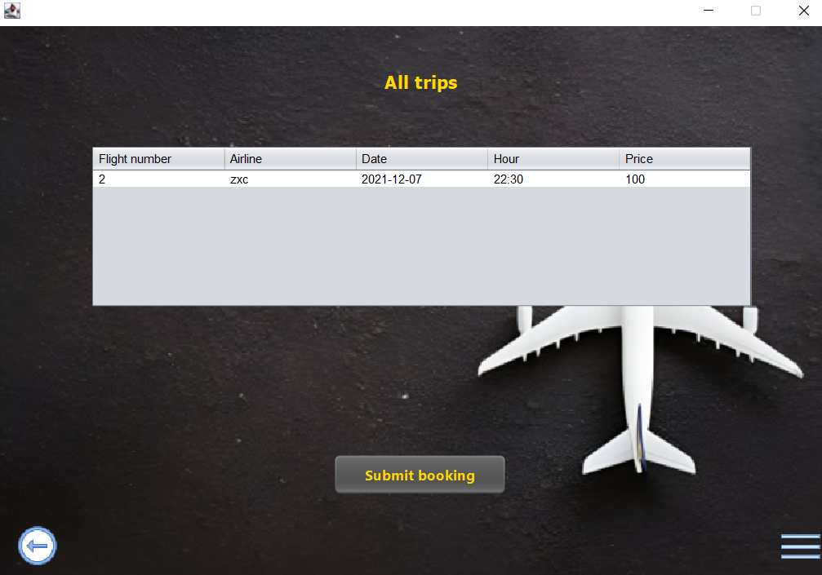

**Ticket information:**

It appears when you click on the ticket information in the main menu, showing the various flights that the customer has booked.

When you press the main menu button, it will go to the main menu.

When you click on the delete button, you must have chosen a flight from the table that you want to delete before you click and you will work to delete it from the database or a message appears if you have not selected from the table.

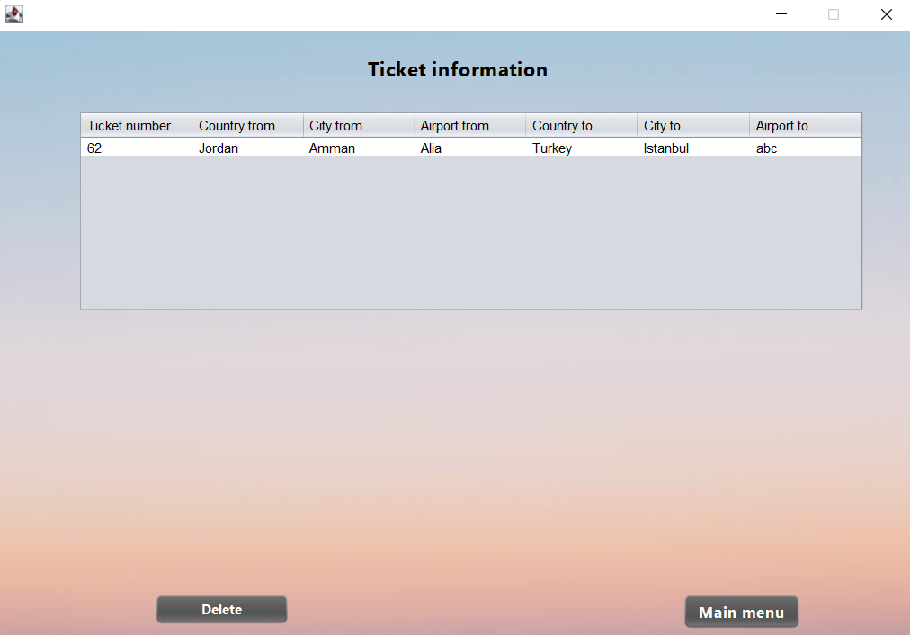

**Ticket information 2:**

When selecting a flight from the tabel (from flights previously booked by the customer), its information will appear in Textfield as shown in the design

When you press the main menu button, it will go to the main menu.

When you click the delete button, you must have chosen a flight from the table that you want to delete before clicking on it and it will delete it from the database or a message appears if you have not selected from the table.

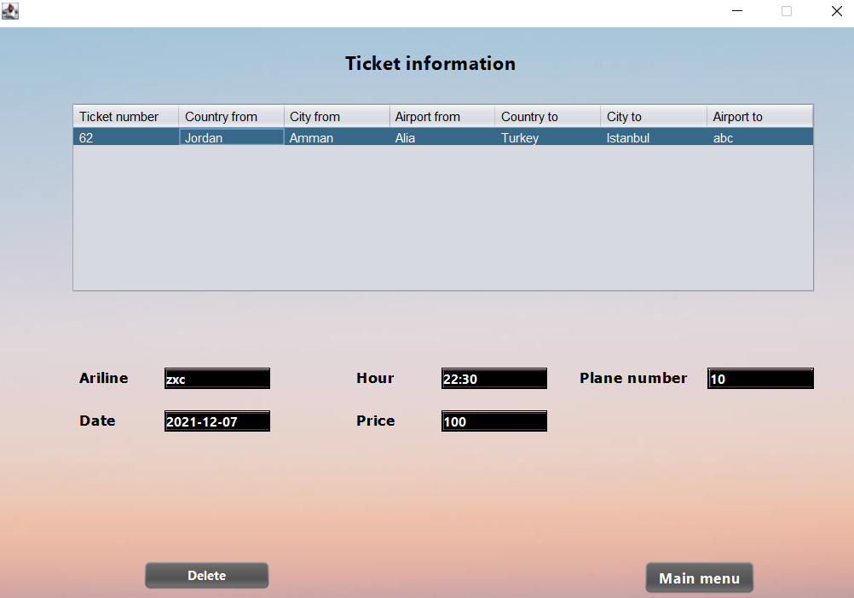

**Hotel Address:**

It appears when you click on the room booking button from the main menu, where you choose the hotel address (country and city).

When you click on the following, you go to the table of hotels located at this address.

At the bottom of the right screen it contains an Apple in the form of three shatters. When you click on it, it goes to the main menu, and the bottom left contains an Apple in the form of an arrow that returns to the page before it.

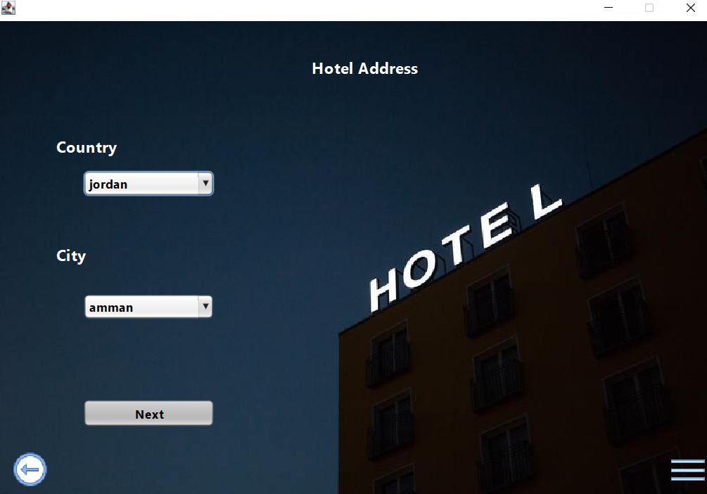

**Hotels:**

it appears when you click on Next in the hotel address, as it contains a table showing all the hotels in the address you chose previously with regardless of the information about each hotel (the hotel number, the name of the hotel,evaluation, the street in which it is located).

And when you press next, you go to the date booking.

At the bottom of the right screen it contains an Apple in the form of three shatters. When you click on it, it goes to the main menu, and the bottom left contains an Apple in the form of an arrow that returns to the page before it.

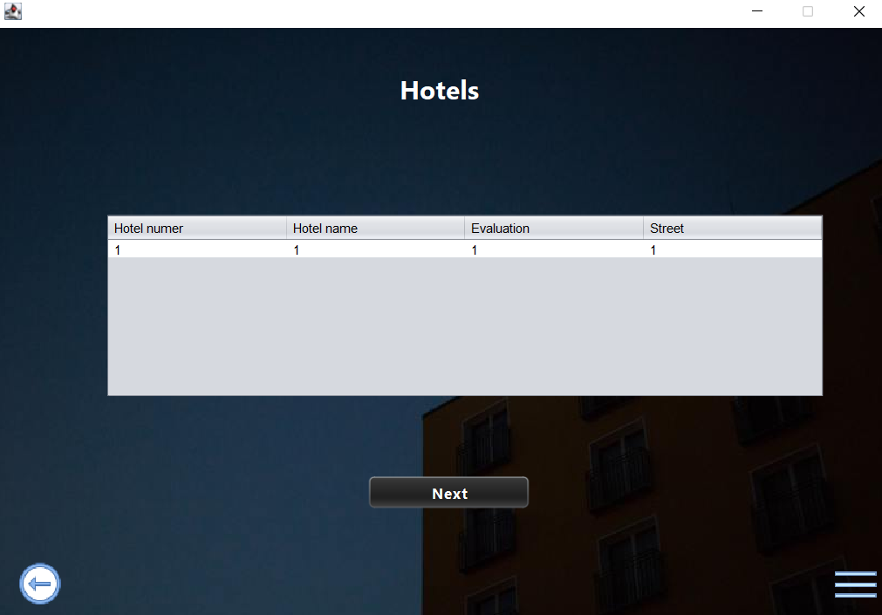

**Book Date:**

The Book date appears when you click on the next button in the hotels, where you choose the date of check-in and check-out.

And when you click on the next button, the available rooms that are compatible with your choice of the date you want and the hotel you chose previously will appear.

At the bottom of the right screen it contains an Apple in the form of three shatters. When you click on it, it goes to the main menu, and the bottom left contains an Apple in the form of an arrow that returns to the page before it.

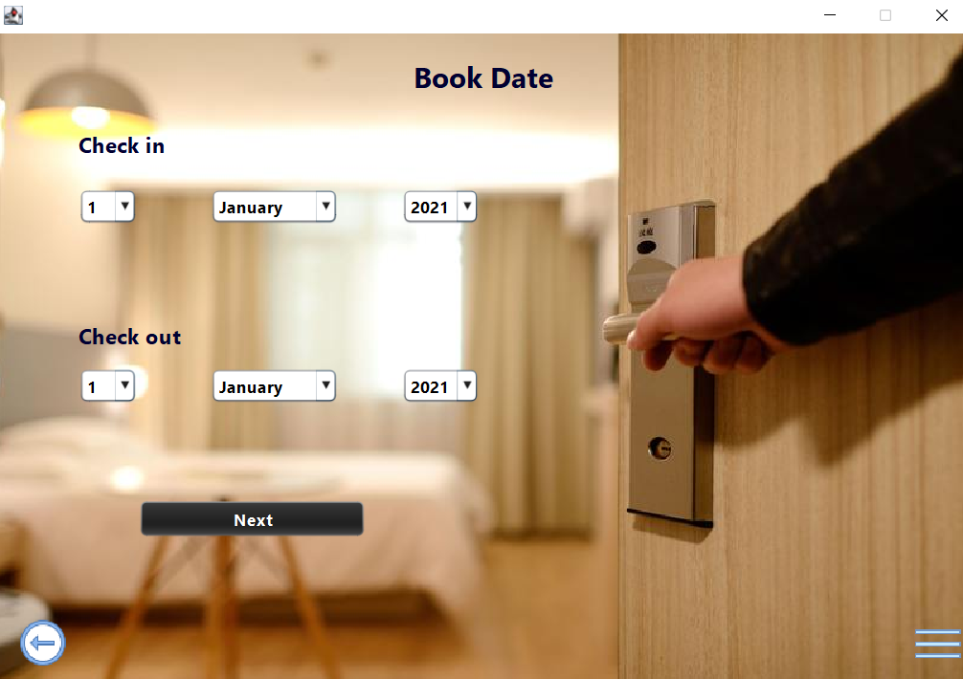

**Rooms:**

At appears when you click on Next in hotels, where the table displays all the available rooms in the hotel he chose and is empty for the period he wants to book with some of its information (price, type, room number, number of people).

He clicks on the room he wants, then presses the submit button, and the reservation is stored in the data base and has been booked and then returns to the main menu.

If Guy does not choose a room from the table and press submit, a message will appear to him.

At the bottom of the right screen it contains an Apple in the form of three shatters. When you click on it, it goes to the main menu, and the bottom left contains an Apple in the form of an arrow that returns to the page before it.

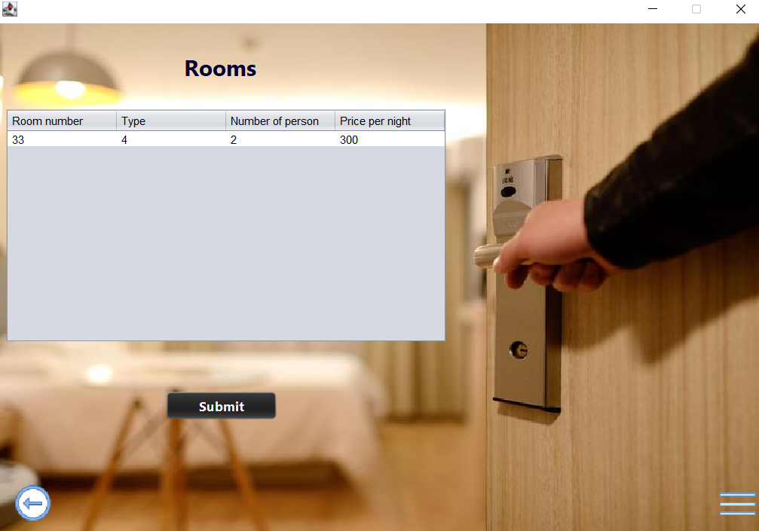

**Room Information:**

At appears when you click on My Room Info in the main menu.

The table displays some information about the room (room number, room type, number of people, check-in date, check-out date).

When you press the main menu button, it will go to the main menu.

When you click on the delete button, you must have chosen a room from the table that you want to delete before you click and you will work to delete it from the database or a message appears if you have not selected from the table.

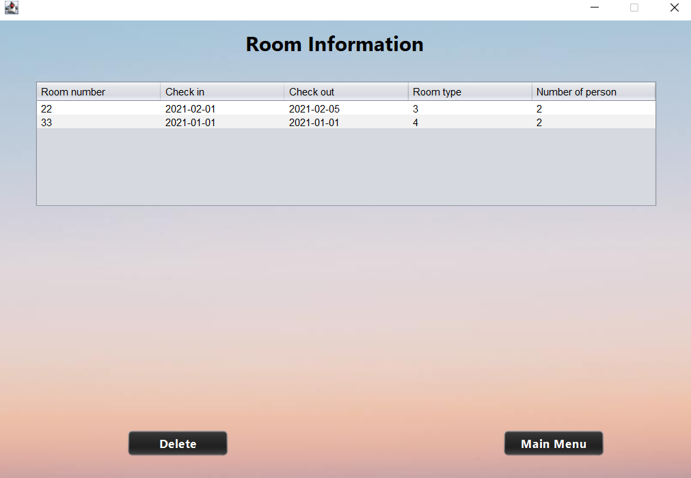

**Room Information2:**

When selecting a room from the table (from the rooms previously booked by the customer), its information will appear in Textfield as shown in the design

When you press the main menu button, it will go to the main menu.

When you click the delete button, you must have decided which room of the Table you want to delete before clicking on it and you will delete it from the database or a message appears if you did not select it from the table.

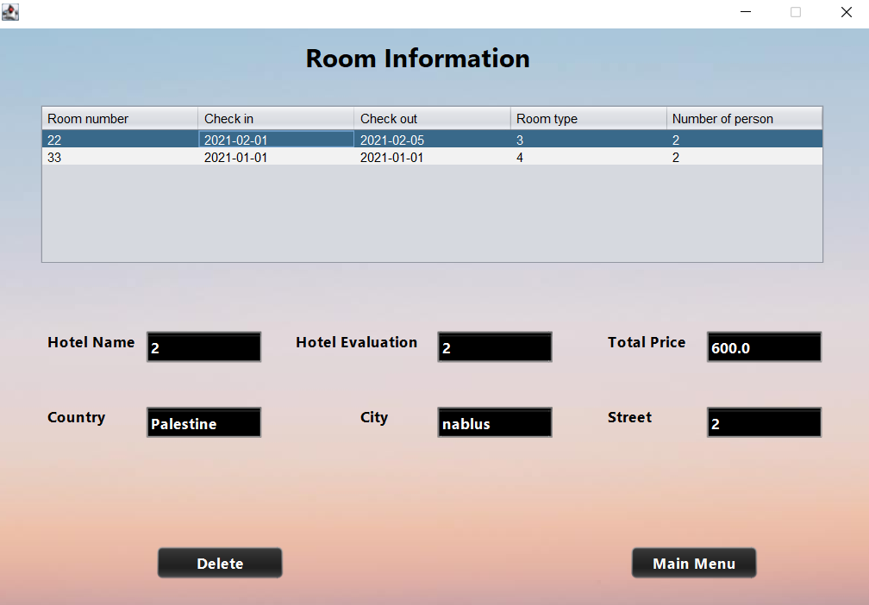

**Conclusion:**

In conclusion, we built our project "Online Booking System", which worked on many of the problems of tourists and made it easier for them to make reservations and know the trips.

We learned sql and built a database for our project with its middle, and also we built an interface and we linked it to the database using jbdc and we used many tools such as Netbeans and we knew how important a relational database is for accessing, storing, modifying and deleting information and that dealing It is easier and more efficient.

**Refrences:**

* Stack OverFlow

<https://stackoverflow.com/>

* Oracle Help Centre

<https://docs.oracle.com/en/>

* RGB

 <https://www.rapidtables.com/web/color/RGB_Color.html>

* Jasperreports

<https://sourceforge.net/projects/jasperreports/>

* Java T point

<https://www.javatpoint.com/dbms-functional-dependency>

* youtube

https://www.youtube.com/